**Program Six Part One:**

//summary: This program displays the first 100 pentagonal numbers by using methods

//name: Jenna Wolf

//class: Fundamentals of Programming, CS155 - 01

//instructor: Dr. Art Kazmierczak

//date: 9/25/2023

public class Main

{

public static void main(String[] args)

{

int count = 0; //holds the count data and sets it to 0

//displays what the program does

System.out.println("This program displays the first 100 pentagonal numbers with 10 on each line");

//for loop the creates n and sets it to 1, makes sure n is less than 101, and adds 1 to n each time

for(int n = 1; n < 101; n++)

{

//calls the getPentagonalNumber method and outputs it

System.out.print(getPentagonalNumber(n) + " ");

count++; //adds 1 to count

//when count is 10, it ends the current line

if(count == 10)

{

count = 0;

System.out.println();

}

}

}

//this method finds the pentagonal number for a integer and returns it

public static int getPentagonalNumber(int n)

{

return n * (3 * n - 1) / 2; //returns the number computed by the equation

}

}

Outputs:

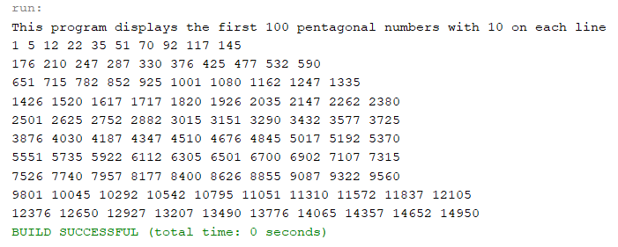

**Program Six Part Two:**

//summary: This program takes 3 numbers from the user and orders them from lowest to highest

//name: Jenna Wolf

//class: Fundamentals of Programming, CS155 - 01

//instructor: Dr. Art Kazmierczak

//date: 9/25/2023

import java.util.Scanner; //allows inputs to be made

public class Main

{

public static void main(String[] args)

{

Scanner input = new Scanner(System.in); //labels input as input

double numA, numB, numC; //holds the numA, numB, and numC data

//takes in the three numbers from the user

System.out.print("Please enter your first number: ");

numA = input.nextDouble();

System.out.print("Please enter your second number: ");

numB = input.nextDouble();

System.out.print("Please enter your third number: ");

numC = input.nextDouble();

//calls the displaySortedNumbers method

displaySortedNumbers(numA, numB, numC);

}

//orders the three numbers entered by the user and displays them

public static void displaySortedNumbers( double num1, double num2, double num3)

{

double temp; //holds the temp data

//checks to see if num2 is less that num1 and num3

if(num2 < num1 && num2 < num3)

{

//switches num1 and num2

temp = num1;

num1 = num2;

num2 = temp;

}

else if(num3 < num1 && num3 < num2) //checks to see if num3 is less than num1 and num2

{

//switches num1 and num3

temp = num1;

num1 = num3;

num3 = temp;

}

//checks to see is num3 is less that num2

if(num3 < num2)

{

//switches num2 and num3

temp = num2;

num2 = num3;

num3 = temp;

}

//outputs all numbers in ascending order

System.out.println("Lowest: " + num1);

System.out.println("Middle: " + num2);

System.out.println("Highest: " + num3);

}

}

Outputs:

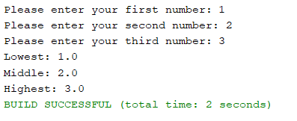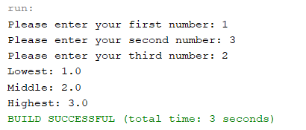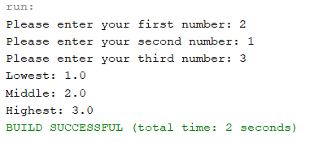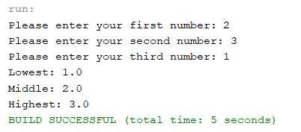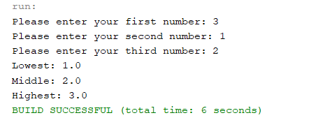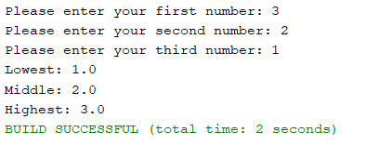

**Program Six Part Three:**

//summary: Caculates and displays the difference from feet and meters for feet 1-10 (plus 1 every time)

//and meters 20-65 (plus 5 every time)

//name: Jenna Wolf

//class: Fundamentals of Programming, CS155 - 01

//instructor: Dr. Art Kazmierczak

//date: 9/25/2023

public class Main

{

public static void main(String[] args)

{

double foot = 1, meter = 20; //holds the foot data (set to 1) and the meter data (set to 20)

//says what the program does and outputs the header

System.out.println("This program displays the conversion from feet to meters");

System.out.println("Feet Meter | Meter Foot");

//for loop that creates int i set to 0, makes sure i is less than 10, and adds 1 to i each time

for(int i = 0; i < 10; i++)

{

//outputs a chart of the feet and meters. also calls the methods

System.out.printf("%-8.1f", foot);

System.out.printf("%-8.3f", footToMeter(foot));

System.out.print("| ");

System.out.printf("%-8.1f", meter);

System.out.printf("%-8.3f", meterToFoot(meter));

System.out.println();

foot++; //adds 1 to foot

meter = meter + 5; //adds 5 to meter

}

}

//caculates and returns the conversion from foot to meter

public static double footToMeter(double foot)

{

return 0.305 * foot; //returns the caculated value

}

//caculates and returns the conversion from meter to foot

public static double meterToFoot(double meter)

{

return 3.279 * meter; //returns the caculated value

}

}

Outputs:

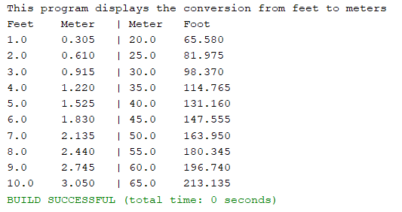

**Program Six Part Four:**

//summary: takes in the user input and created a matrix of n by n of 0's and 1's (random)

//name: Jenna Wolf

//class: Fundamentals of Programming, CS155 - 01

//instructor: Dr. Art Kazmierczak

//date: 9/25/2023

import java.util.Scanner; //allows inputs to be made

import java.util.Random; //allows random numbers to be generated

public class Main

{

public static void main(String[] args)

{

Scanner input = new Scanner(System.in); //labels input as input

int num; //hold the num data

//takes in a integer from the user

System.out.print("Please enter any Integer and this program will make a matrix of n by n with 0's and 1's: ");

num = input.nextInt();

printMatrix(num); //calls the printMatrix method

}

//displays a matrix of size n by n of random 0's and 1's

public static void printMatrix(int n)

{

Random rand = new Random(); //labels random as rand

//for loop that creates the int i at 0, makes sure i is less than n, and adds 1 to i each time

for(int i = 0; i < n; i++)

{

//for loop that creates the int j at 0, makes sure j is less than n, and adds 1 to j each time

for(int j = 0; j < n; j++)

System.out.print(rand.nextInt(2) + " "); //displays the random 1 or 0 with a space

System.out.println(); //prints a line

}

}

}

Outputs:

